Electricity Billing Management System

Table of Contents
Introduction:
Scenario:
Basic rules for electricity bill management as a business:
ER Diagram:
Normalization Process:
Database Creation:
General Issues to be discussed:
Security, Integrity, and ethical aspects of data governance applied to the company:
I. Scenario:
II. Conclusion:
III. Reference:

Introduction:
Managing customer bills, meter readings, billing data, and maintenance records are all part of the electric company scenario. The employer provides energy to business, residential, and commercial clients; this necessitates effective administration of various power distribution components.

Scenario:
Keeping track of customer accounts, meter readings, billing data, and maintenance information are all part of the electric organization issue. Efficient management of diverse aspects of strength distribution is necessary for the organization to provide power to residential, commercial, and industrial consumers.
The employer in this scenario is required to create bills for clients, record meter readings on a regular basis, and handle meter preservation requests. Meter readings are the main source of information used to bill customers, and they record how much energy they use. Customers may have a few meters associated with their account, and each has an entirely unique account wide variation. To guarantee accuracy and safety, meters are serviced once a year.
To effectively manage its operations, the company needs data on client debts, meter readings, billing history, and refurbishment records. This information is utilized to provide customer service, maintain timetables, and compute payments.

Basic Rules for electricity bill management as a business:
- Billing Rules: Users are billed based on their electricity usage, which is calculated using meter readings.
- Meter Reading Schedule: Meter readings are taken monthly for residential users and bi-monthly for commercial and industrial users.
- Maintenance Schedule: Meters are maintained annually to ensure accuracy and safety.
- User Account Management: Each user has a unique account number and can have multiple meters associated with their account.
Information Needs:
- User Information: Name, address, contact number, account number.
- Meter Information: Meter number, location, last reading date, and previous reading value.
- Billing Information: Billing date, billing amount, payment status.
- Maintenance Information: Maintenance date, maintenance description, maintenance record

ER Diagram Scenario:
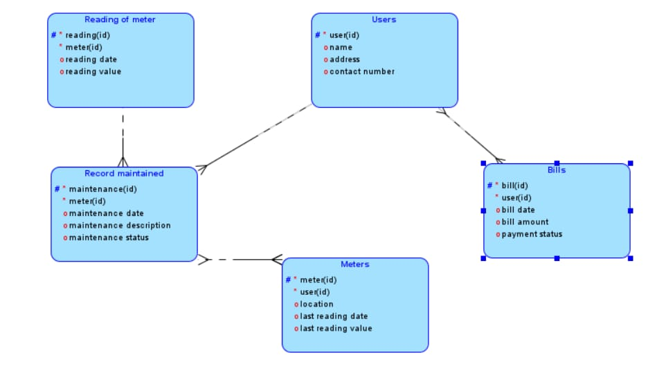

Normalization Process
- Reading of meter
- Record maintained
- Users
- Meters

- Bills
- Meter reading
  - Table Name: Reading of meter
  - Primary Key: reading(id)
  - Foreign Key: meter(id)
  - Attributes: reading(id), Meter(id), reading date, reading value

- Maintenance Records
  - Table Name: Record maintained
  - Primary Key: maintenance(id)
  - Foreign Key: meter(id)
  - Attribués: maintenance (id), meter (id), maintenance date, maintenance description, maintenance statuts
- Users
  - Table Name:
  - Primary Key: User(id)
  - Attributes: : user(id), name, address and Contact number IE(Cell phone or email ID)
- Meters
  - Table Name: Meters
  - Primary Key: meter(id) By User
  - Foreign Key: user(id)
  - Attributes: meter(id), user(id), location, last reading date, last reading value.

- Bills
  - Table Name: Bills
  - Primary Key: bill(id)
  - Foreign Key: user(id) (references Users. User(id))
  - Attributes: bill(id), user(id), bill date, bill amount, payment status

Data Base Creation:
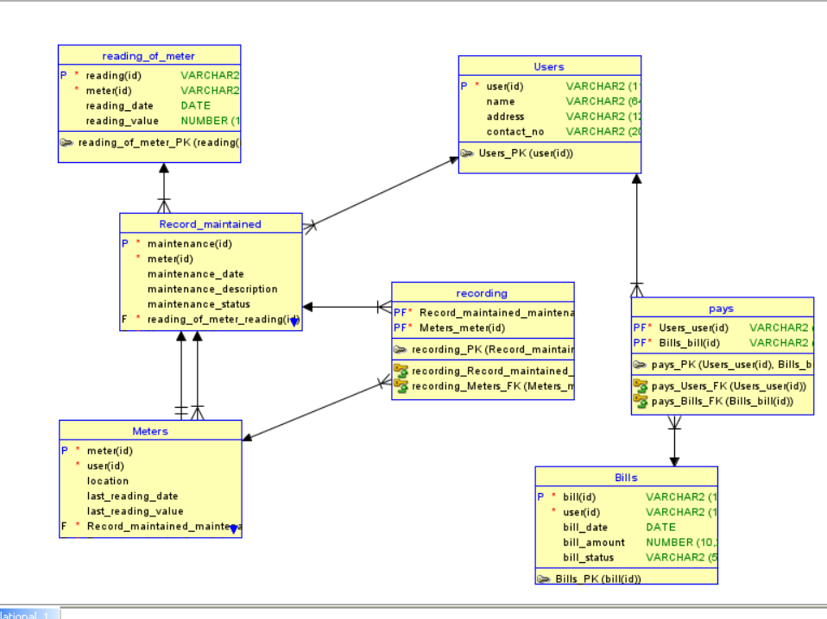
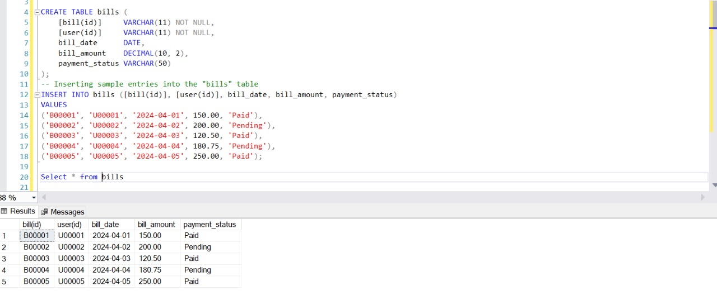

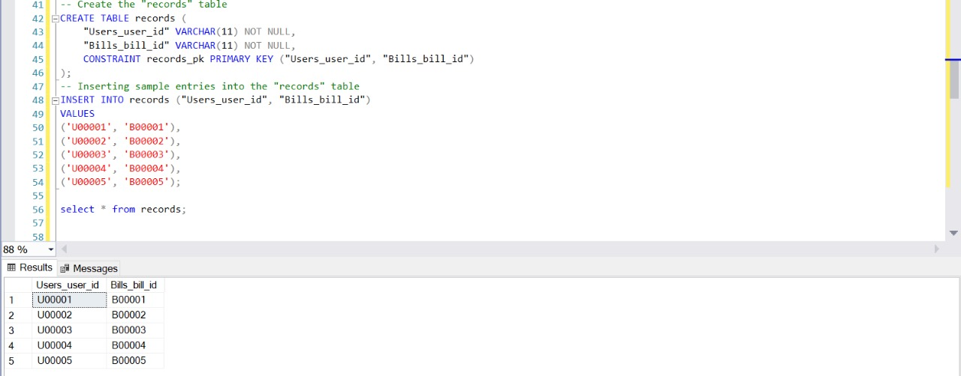
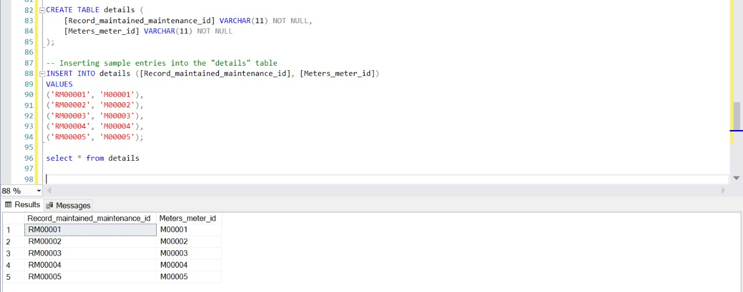
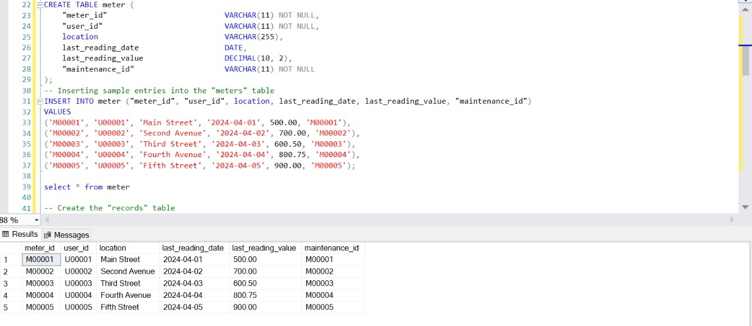

II.2.a) General Discussion and Reflection of Security, Integrity, and Ethical Aspects of Data Governance
- Security:
Data safety includes defensive records from unauthorized get entry to, use, disclosure, disruption, modification, or destruction. It consists of implementing safety features together with encryption, get entry to controls, and ordinary security audits. Security breaches can lead to loss of touchy information, financial loss, and damage to an organization’s reputation.
- Integrity:
Data integrity refers back to the accuracy, consistency, and reliability of information in the course of its lifecycle. It guarantees that records isn't always altered or corrupted in an unauthorized or accidental manner. Maintaining statistics integrity entails implementing mechanisms inclusive of records validation, mistakes detection, and get admission to controls to prevent unauthorized changes to statistics.
- Ethical Aspects:
Ethical concerns in statistics governance involve making sure that records is accumulated, used, and managed in a responsible and moral way. This consists of acquiring consent for facts series, protective the privateness of individuals, and using facts for legitimate functions. Ethical records governance additionally involves transparency, accountability, and equity in facts practices.

II.2.b) Security, Integrity, and Ethical Aspects of Data Governance Applied to the Electric Company Scenario
- Security:
  - Data Protection: Implement measures to protect customer data, such as encryption, access controls, and regular security audits.
  - Secure Communication: Use secure channels for communication, such as HTTPS, to protect data transmission between customers, meters, and the company's database.
  - Access Controls: Limit access to sensitive data to authorized personnel only and implement role-based access controls.
- Integrity:
  - Data Validation: Ensure that meter readings and billing information are accurate and consistent to maintain data integrity.
  - Error Detection: Implement mechanisms to detect and correct errors in meter readings and billing data to prevent data corruption.
  - Audit Trails: Maintain audit trails to track changes to data and ensure that any modifications are authorized and documented.
- Ethical Aspects:
  - Privacy Protection: Obtain customer consent for data collection and use, and ensure that customer data is protected from unauthorized access or disclosure.
  - Fair Use: Use customer data only for legitimate purposes, such as billing and maintenance, and avoid using it for unrelated or unethical purposes.
  - Transparency: Be transparent about data collection and use practices, and provide customers with clear information about how their data is used and protected.

Conclusion
Powerful records governance is paramount for ensuring the safety, integrity, and ethical use of data, particularly in scenarios just like the electric powered organization in which consumer records and operational statistics are vital. By enforcing sturdy safety features, ensuring facts integrity through validation and blunders detection, and adhering to ethical ideas such as privacy safety and fair use of data, corporations can construct agree with their customers and keep the reliability in their facts. It is crucial for businesses to constantly review and update their statistics governance regulations to address evolving protection threats and ethical issues in facts control.

References
- Wang, R. Y., & Strong, D. M. (1996). Beyond accuracy: What data quality means to data consumers. Journal of management information systems, 12(4), 5-34.
- Inmon, W. H., & Linstedt, D. (2014). Data architecture: A primer for the data scientist. Newnes.
- Hurwitz, J., Nugent, A., Halper, F., & Kaufman, M. (2013). Big data for dummies. John Wiley & Sons.

